**HOMEWORK 2:**

**BA WITH R**

**SUBMITTED BY :- Abhishek Arya**

**NETID: axa220149**

Answer (1-1):

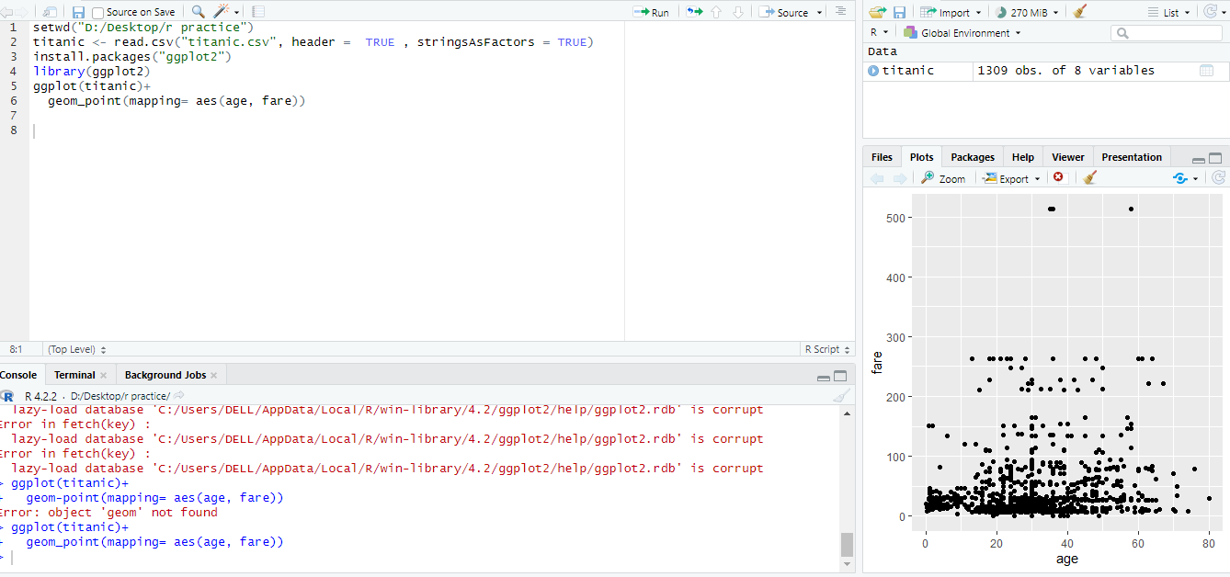

Answer (1-2):

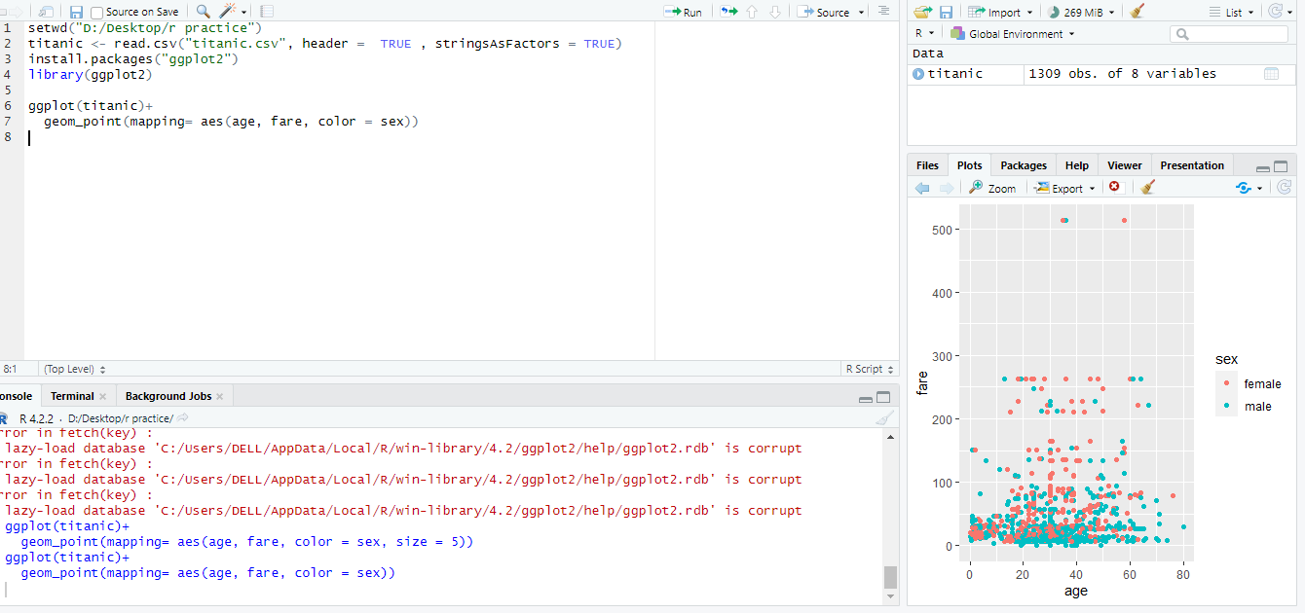

Answer (1-3):

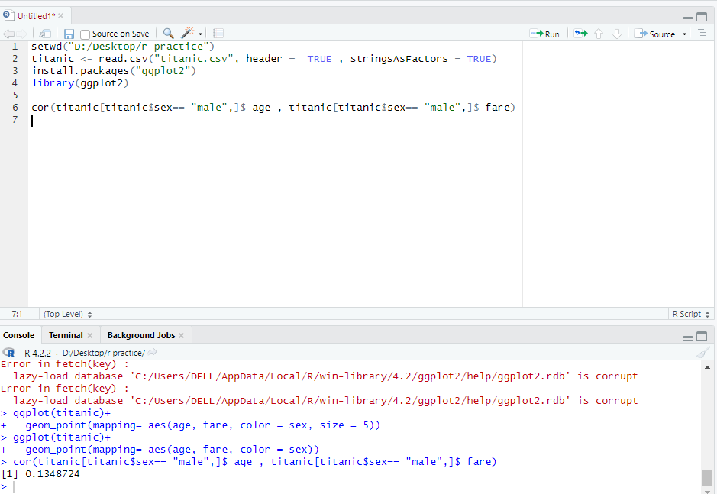

Answer (1-4):

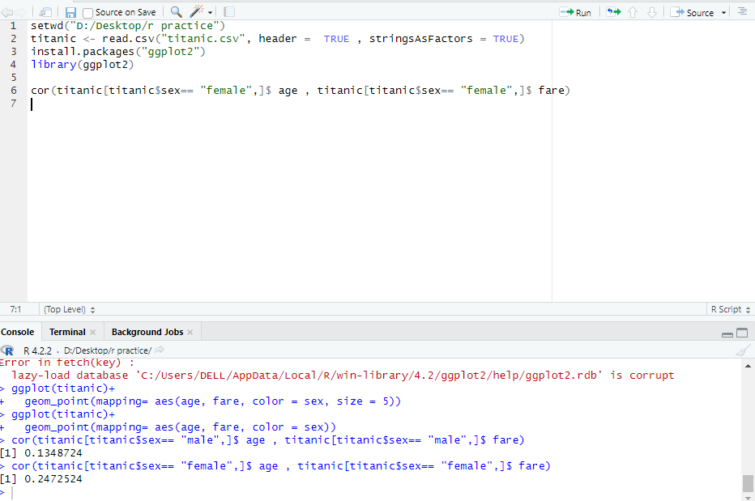

Answer (2-1):

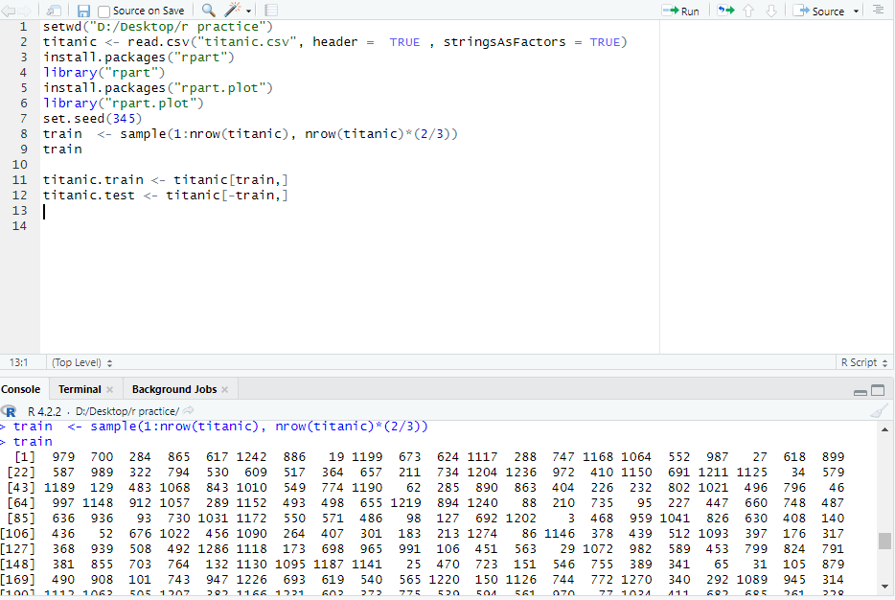

Answer (2-2):

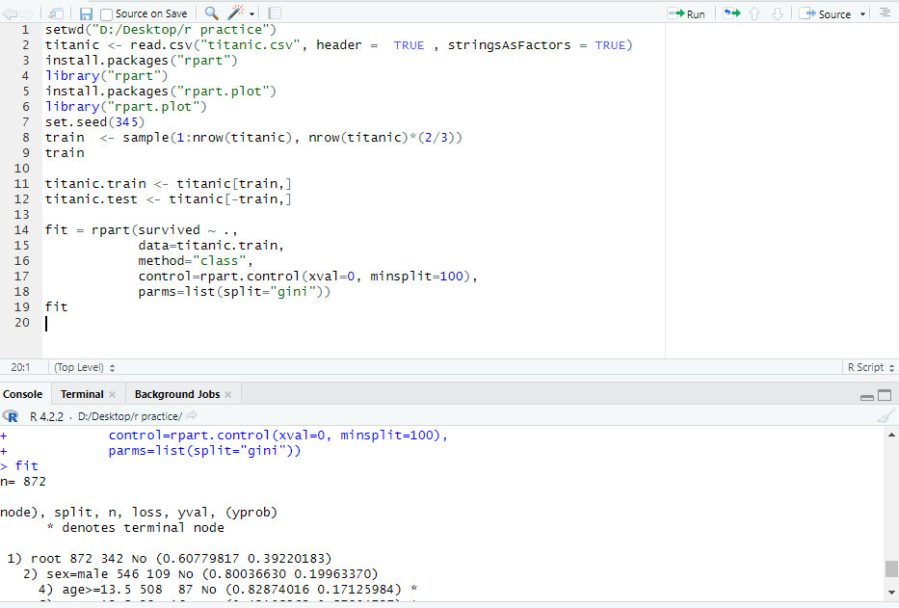

Answer (2-3):

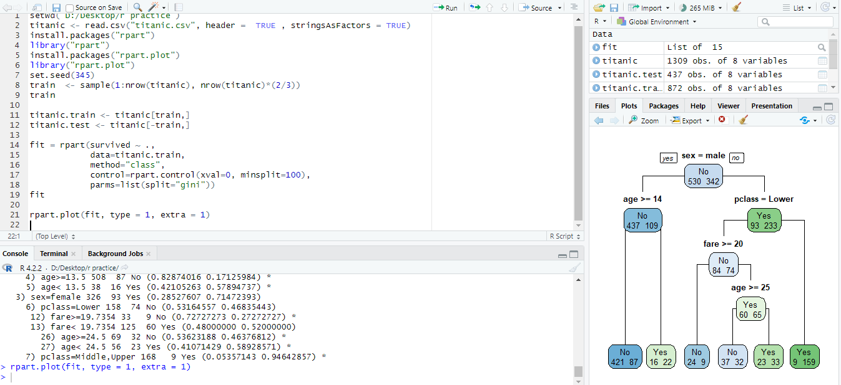

Answer (2-4):

